# REQUEST: 6939

**From:** Soh, Ivy   
**Sent:** Wednesday, 31 January, 2018 11:16 AM  
**To:** Chan, Pei-Fong  
**Cc:** Susan, Chong; Tan, Daniel; Tan, Yan Zhang; Chan, Kim Lan; Ng, Crystal; Ng, Xiang Yue  
**Subject:** SNOWBALL (Amazon WMS)

Hi Pei Fong,

Can you please create a New Ship to code: **Snowball** (GST Paid Item) for Amazon WMS. Onboard on 5Feb18.

Ship to Code : **SB** (Snowball).

Requirement for SB :

Receiving

1. Asset# can ‘repeat’. Like OH (on hold) Ship to Code. Items will be assign with New LP#
2. HAWB – Unique (no repeated hawb).
3. 1 ASN = 1 HAWB = multiple Asset#. Like DE Ship to Code.
4. SB current inventory cannot have same/duplicate Asset#. Like OH. Meaning Current Inventory for 5Feb18 cannot have same Asset.

Here’s the Asset ID’s for this snowball shipment.

6403589009

6403589027

6403589023

6403589025

6403589012

6403589028

6403589010

6403589011

6403589014

6403589008

6403589016

6403589013

Regards  
  
Ivy Soh  
Direct Line: (65) 6549-1136  
H/P: (65) 9177-1233  
Email: [ivy.soh@dbschenker.com](mailto:ivy.soh@dbschenker.com)

# WMS CHANGES

## Setup Product category

New Product category SB , Billing group = SNOWBALL

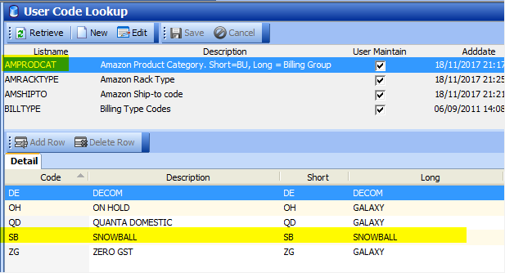

## Setup Ship-toCode

Ship-to code – SB

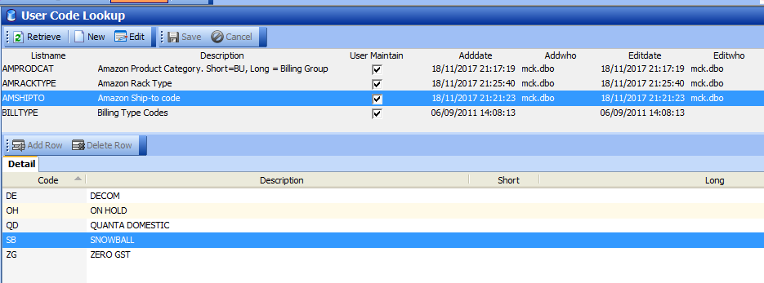

## ASN Creation

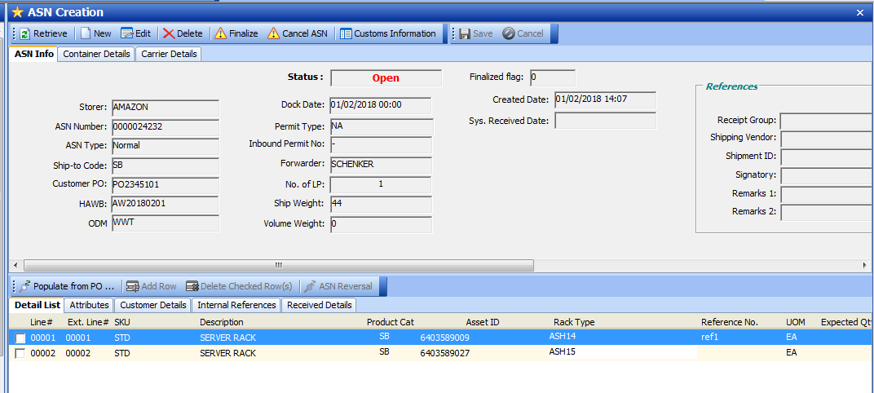

### Validation HAWB Unique:

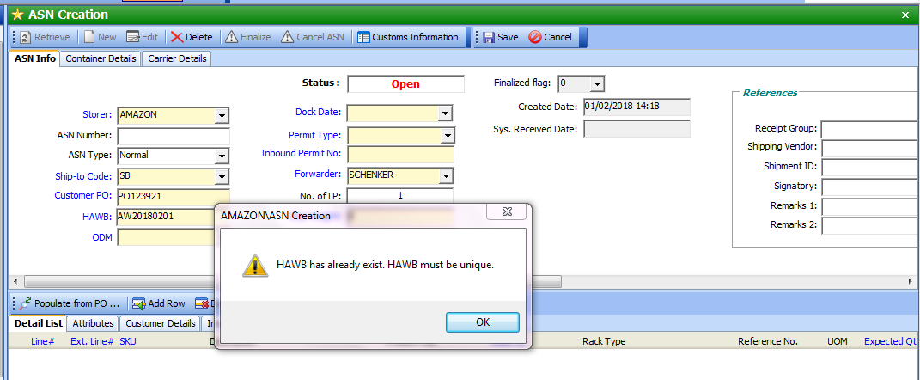

### Validate Asset ID

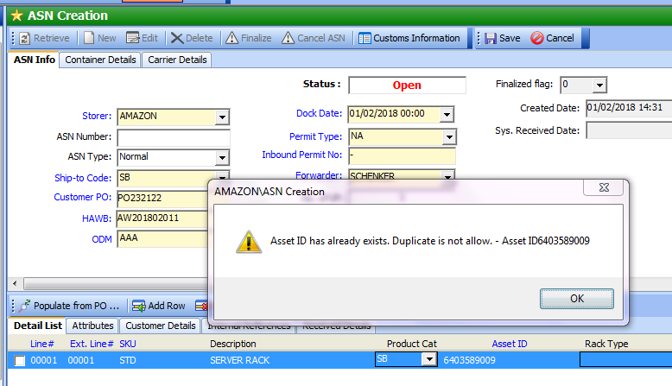

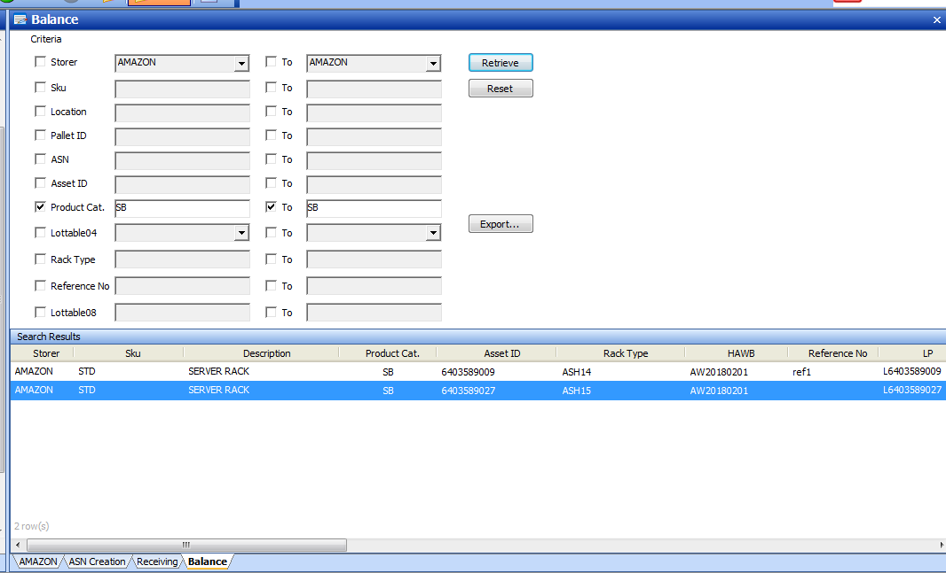

## Daily Receiving report

** no changes. able retrieve by Billing Group = SNOWBALL

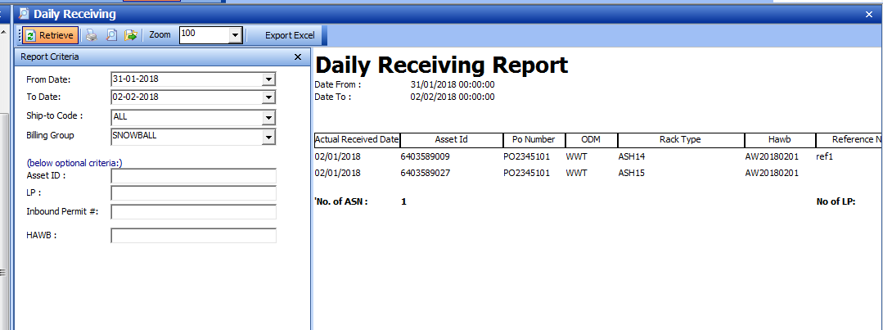

## Orders Creation

** no changes;

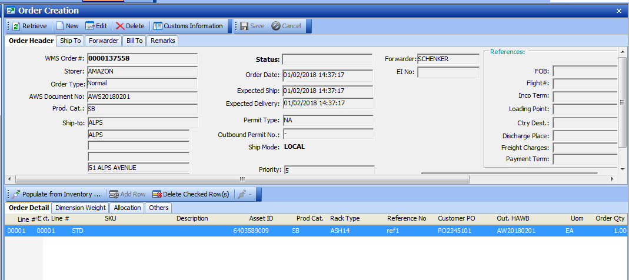

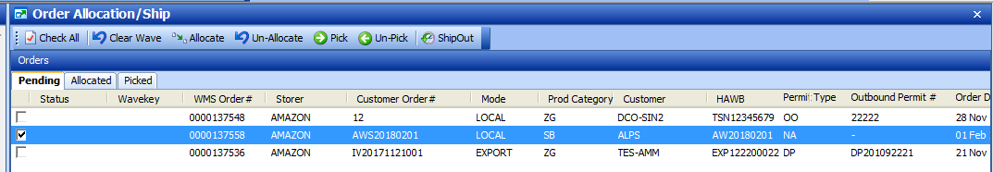

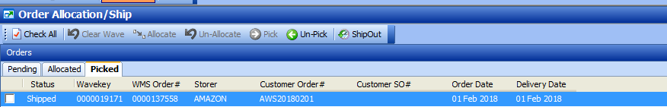

## Daily Outgoing

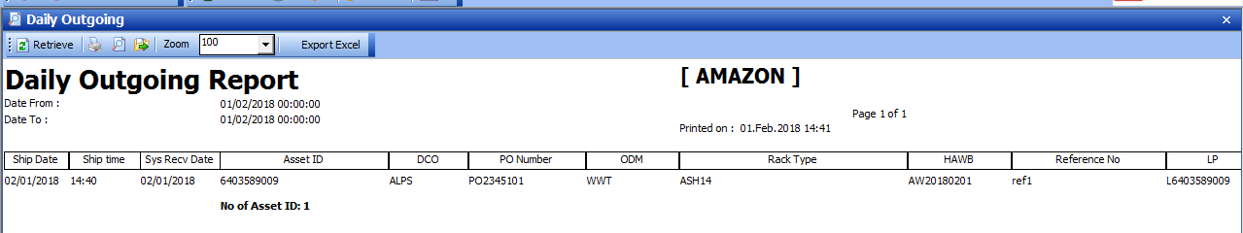

## Inventory Report

